Chapter 8- Political Geography Notes - Part II
Core
- _____________ states have assumed their current shape following centuries of growth
- Examples: _________________________________________________________
Periphery
- The ___________________ of the core area thin the farther you move outward
- Any resource benefits of the periphery are typically _____________________backed to the core
- Examples: ______________________________________________________________________
Semi-Periphery
- Exploited by the __________________, and exploit the periphery
- Examples: ______________________________________________________________________
Boundaries
- _______________________ that establish the limit of each state’s jurisdiction and authority
- Claims and boundaries are 3 dimensional
  - ______________________________________________________________
  - Airspace extends into airline traffic (satellites next?)
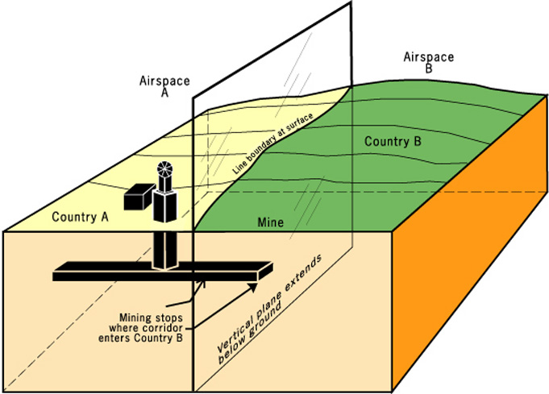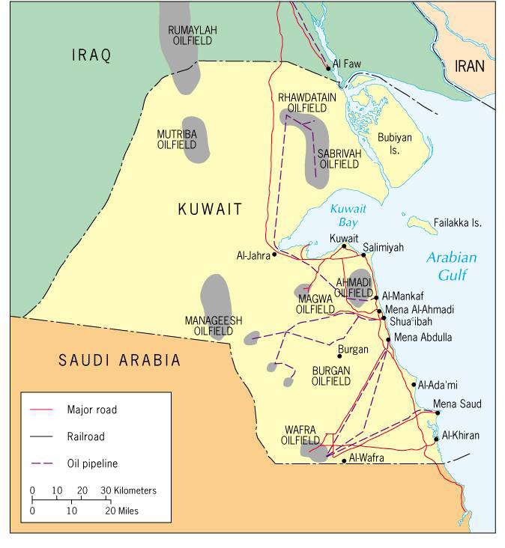
The Evolution of Boundaries
- Definition: the official establishment or documentation of a boundary
  - ___________________________________
  - ___________________________________
  - Example: 2000 Macedonia-Serbia and Montenegro delimitation agreement
- Delimitation: placing of the boundary on a map
- Demarcation: marking of the boundary by some method on the ground
Boundary Types
  - _______________________________________________
    - 12 Nautical miles
  - Contiguous Zone
    - 12 Nautical miles
  - __________________________________________________________
    - 200 Nautical Miles
Gibraltar
- Sovereignty
  - Should they be allowed to choose what country?
  - Does Gibraltar have the right?
Boundary Types
- _____________________________: follows parallels of latitude and meridians of longitude
  - 49th parallel United States & Canada
  - Africa, Asia, Americas
- _________________________: separate groups by a common cultural trait
  - India and Pakistan
- ____________________________________: border drawn before it was well populated
  - United States & Canada
- _______________________________________________: border drawn to accommodate existing religious, linguistic, or ethnic differences
  - N. Ireland and Ireland
- _____________________________________________________________: forced on an existing cultural landscape, country, or people by a conquering colonial power
  - Unconcerned about preexisting cultural patterns
  - Ex: ________________________________________________
- __________________________________________: former boundary that no longer functions
  - Differences on each side of the border are still evident
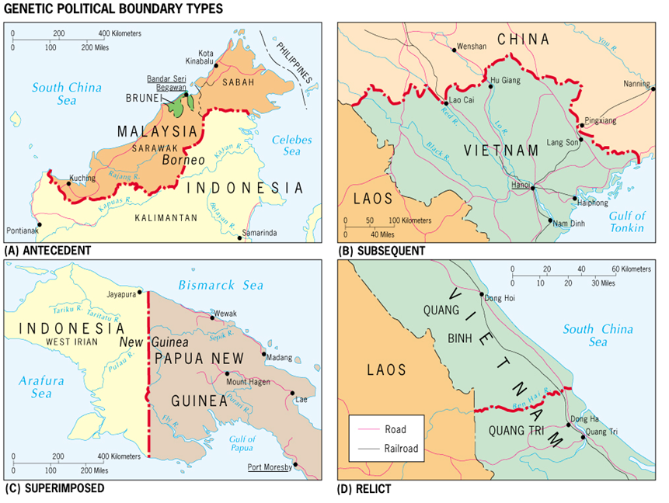

Definitional/Positional Boundary Disputes
- Focus on the ______________________________ language of the boundary agreement
- A boundary _______________________________ may base a boundary on a _______________________________________ that has moved or no longer visible
Ex. Argentina and Chile
Allocation/Resource Disputes
- Neighboring states can argue about the distribution of resources
Ex. _______________________________________
Ex. ________________________________________
Territorial Disputes
- A _________________________________ boundary divides an ethnically homogenous group
- _________________________- advocating annexation of territories administered by another state on the grounds of common ethnicity or prior historical possession
- Ex. ____________________________________________
Capitals
- Typically are ____________________________ located to allow for equal access
- Many capitals have become _______________ to many areas due to growth: Washington D.C.
- Some capitals have been _________________________________ to make the more accessible
Forward-Thrust capital City
- Deliberately sited in a state’s ___________________________
- Ex. Brazil relocated its capital from Rio de Janeiro to a new city called ____________________
- Ex. Nigeria – _____________________
- Ex. Kazakhstan – ____________________________

